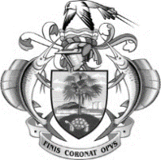

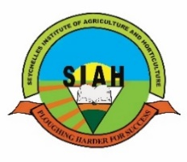Seychelles Institute of Agriculture and Horticulture

Anse a La Mouche

P.O. Box 48, Mont Fleuri, Republic of Seychelles

Tel: 4371290

Email Address: [minesiah1@gmail.com](mailto:minesiah1@gmail.com)

*Please address all correspondence to the Director*

**RE: PESTICIDE TRAINING AGREEMENT**

An agreement made this ………….………………………day of…………………………….…………………. between Seychelles Institute of Agriculture and Horticulture and……………………………………..............

......................................................................................................................................................................

(Company/Organisation/Participant).

* Fee per person is SR1500.00 for 2 days.
* The training start from 8.30am to 1.45pm. (Tea Break 30 mins & Lunch 45 mins)
* Refreshment and lunch will be provided, subjected to chosen option/package. (At SIAH-refreshment, snacks and lunch include, other locations, organisations will cater for food and beverages)
* Payment should be made at least 5 working days in advance before the start of the training date. Cheque to be drawn on **Government of Seychelles.**
* Upon completion Certificate of Competence will be awarded to the participant or funding organization.
* Minimum participants 10
* Maximum participants 12
* **N.B:** For training conducted outside of the organization, the training fee will vary related to services, resources, courier fees, materials being provided.

Note that the certificate is valid for three years.

If agreed to the terms and conditions above, please endorse the form.

Participant Name: -----------------------------------------------------------------

**Official Stamp of your Organisation**

Organization/Company Name: ------------------------------------------------------------

Organization /Company Manager: -------------------------------------------------------

Date:------------------------------

Thank you for your cooperation.



**Maryanne Marie (Ms)**

**Director SIAH**